March 26, 2025

Usability Analysis of Clawworldusa.com
By Katarina Hung


[ADDRESS REDACTED]

Las Vegas, Nevada

26 March 2025

Claw World

8665 West Flamingo Road, Unit 119

Las Vegas, NV 89147

Re: Usability Analysis Report

Dear Claw World,

The purpose of this letter is to detail the contents of the attached final report for our usability testing of ClawWorldUSA.com.

For this project, we implemented user testing through online questionnaires and data visualization. From the user testing and data analysis we concluded that ClawWorldUSA.com has some issues that cause some users to be dissatisfied with using the website. These issues include a lack of organization, a lack of visual appeal, and a lack of quality photos/videos.

To improve the overall user experience of ClawWorldUSA.com, we recommend reorganizing the contents of the menu options, as well as redesigning the visuals of the website.

If you have any questions on these matters, please contact Katarina Hung at hungl1@unlv.nevada.edu.

Sincerely,

Katarina Hung

Table of Contents
Transmittal Letter 1
List of Figures 3
Executive Summary 4
Usability Testing of ClawWorldUSA.com 4
Problem 4
Solutions 5
Introduction 6
Background 6
Preliminary Evaluation 6
Testing Goals 7
Recommendations 7
Recommendation #1 7
Recommendation #2 8
Recommendation #3 8
Method 8
Pre-Testing 8
During 8
Post-Testing #3 8
Findings 8
Conclusion 9

List of Figures
Figure 1 4
Figure 2 5
Figure 3 8
Figure 4 9

Executive Summary

This section serves as an abstract summary of the final report of our Usability Analysis of ClawWorldUSA.com that follows.

Usability Testing of ClawWorldUSA.com
The objective of this project is to identify any issues with the usability of the website ClawWorldUSA.com and recommend improvements to improve the usability and overall user experience of the website. To determine the usability of the site, we tested a small focus group through questionnaires. From the data we collected, we identified some key issues that were causing usability problems.

Problem
ClawWorldUSA.com has a few usability issues that will be addressed in this report. Firstly, the website lacks organization, making it difficult for users to find relevant information. Secondly, ClawWorldUSA.com isn’t visually appealing, which causes users to have a negative perception of the business. Lastly, the website's photos and videos of the arcade are not engaging for users.

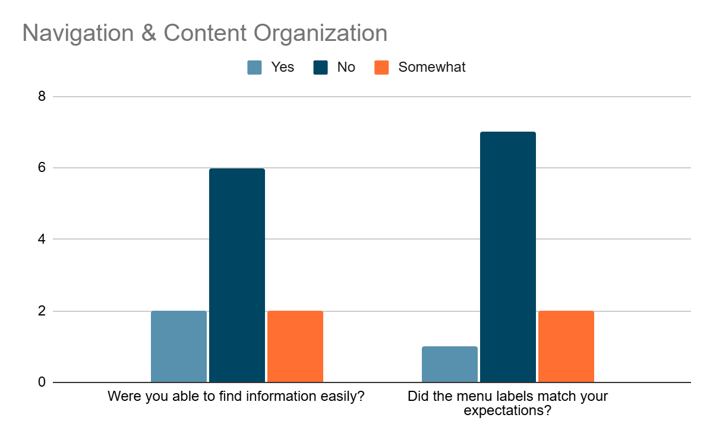
Figure 1 – Bar Chart of Navigation and Content Organization Survey Results

As figure 1 shows, many users had trouble finding information on the website. They also reporting finding information under unexpected menu options. This greatly affect user experience and can cause frustration for some users.

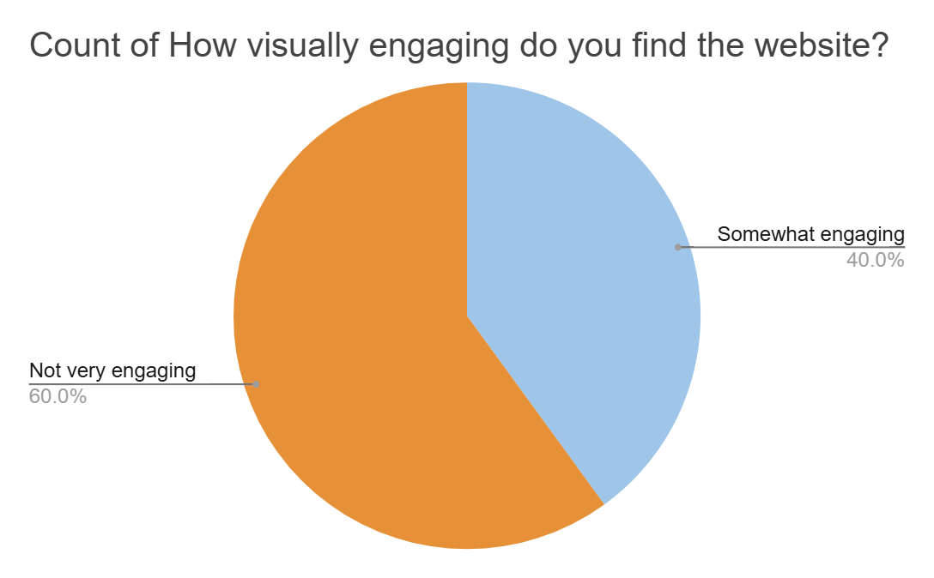
Figure 2 – Pie chart of Visual Engagement Survey Results

This pie chart shows clear problems with the websites’ visual appeal amongst the users tested. We collected data the shows the website lacks in keeping users engaged using photos and videos as well as from the overall design of the website.

Solutions
To address the disorganization problem, we propose reorganizing the information under the menu options and potentially adding and/or removing menu options as necessary. As for the lack of quality multimedia, we recommend adding more videos and pictures of actual gameplay within the facility, as well as pictures of happy customers winning prizes to entice the users to visit Claw World. Additionally, to address this issue, we suggest hiring a professional photographer. Lastly, we advise updating the website's visual elements using more color and adding more dynamic web pages. These solutions will contribute to a happier customer base when using the website.

Introduction

This project’s goal was to assess the usability of the claw machine arcade website ClawWorldUSA.com. Through user testing and evaluation, we have addressed any usability issues that came up throughout this project. Based on our preliminary evaluation, we will address the following issues:

- Content Organization - Navigation and page layout impact east of use
- Dynamic Pages - Issues with slow loading times or interactive elements
- Photos/Videos - Media quality and placement influence clarity and engagement
- Visual Elements - Design consistency, readability, and accessibility

Based on our findings, we have drawn the following conclusions:
- The navigation and content organization needs restructuring to improve accessibility and ease of use.
- Page performance improvements are necessary to ensure seamless user experience and to reduce user frustration.
- Multimedia quality should be made to be more engaging and visually appealing.
- The visual layout and design need to be redone to include more of a color scheme to properly match the feel of the claw machine arcade.

To address these issues, we recommend reorganizing the information under the menu options and potentially adding and/or removing the menu options as necessary. Additionally, we recommend adding more professional videos and pictures of actual gameplay within the facility, as well as pictures of happy customers winning prizes to entice the users to visit Claw World. Lastly, we propose redesigning the website to be more visually appealing and engaging for users.

Background

ClawWorldUSA.com is an arcade and event venue in Las Vegas, Nevada. It’s known for its date-night fun, birthday party packages, and family-friendly entertainment. Claw World features trendy offerings such as TikTok famous ice cream flavors, and collectible Pop Mart Labubu designer toys.

Preliminary Evaluation
Upon our initial visit to ClawWorldUSA.com it’s evident that this website has a more static than dynamic feel to it. Its main page delivers a straightforward UI by displaying its menu options in a row at the top of the page, featuring the following tabs:
- HOME
- VIP MEMBER BENEFITS
- POP MART PRODUCTS

Also, on the home page, after a large photo of the interior of Claw World, are some vertically oriented phone videos displaying the various games found at Claw World. This is followed by a map showing its location and general contact information. The other menu options are similar in that they are all static, short pages, displaying information in the most straightforward manner.

This website is very good at getting to the point and sticking to a two-color color palette for the site. However, the website is disorganized in what information is displayed under each menu option. The website would also benefit from more visual displays of what it offers. Additionally, it can be improved visually.

Testing Goals
We evaluated the following areas:
- Content Organization—Can users find the information they’re looking for under the menu option most fitting to display said information?
- Dynamic Pages—Are the website pages engaging to the user’s eye?
- Photos/Videos—Are there enough good visual representations (using photos and videos) of Claw World that give the user a good and exciting idea of the business?
- Visual Elements—Do the color palettes and over-design of the website add to the user experience without being too distracting?

Recommendations

We recommend reorganizing the contents of the menu options, redesigning the visual elements, and upgrading the photo and videos on ClawWorldUSA.com.

Recommendation #1: Reorganize Navigation
Users consistently reported dissatisfaction and difficulty with finding relevant information. Therefore, we decided the best course of action to reduce this negative user experience is to fully reorganize the menu options and the content under the menu options. We advise removing the extra side menu for website navigation and replacing the current menu options with the following:
- Home
- VIP
- Store
- Gallery
- Book a Private Event
- Contact Us
These new menu options follow a more standard website menu approach and add some more options such as Gallery and Contact Us, as opposed to the previous menu options which were sparse and didn’t contain necessary pages as seen in the screenshot below.
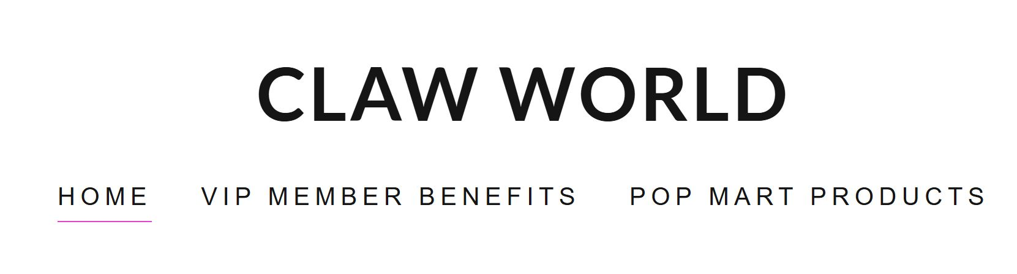Figure 3 – Screenshot of ClawWorldUSA.com menu options

Recommendation #2: Upgrade Multimedia
Our second recommendation addresses the issue of lack of engaging multimedia content. The current content on the website only features two videos that look unprofessional and don’t accurately reflect the fun element of the claw machine arcade. To alleviate this, we suggest hiring a professional photographer who will take more engaging, and presentable photos and videos for the website, and putting said media into the menu option, Gallery.

Recommendation #3: Upgrade Visual Design
Users also reported that the website wasn’t aesthetically pleasing, and so our advice is to redesign the visual elements of the website, perhaps through a professional website designer. The website should stick to a specific color scheme and move away from its current bland white background of each page. Furthermore, the website should implement more dynamic web pages to give a more modern and professional look.

Method
To test the usability of ClawWorldUSA.com, we gathered a small group of 9 people and administered a written questionnaire to each participant.

Pre-Testing
During this pre-testing stage, we asked to collect demographic information from participants to ensure they matched our typical user profile. We also collected information in relation to arcades and claw machines to determine how relevant the data we collect from them is. Figure 3 below shows the results of the questionnaires.
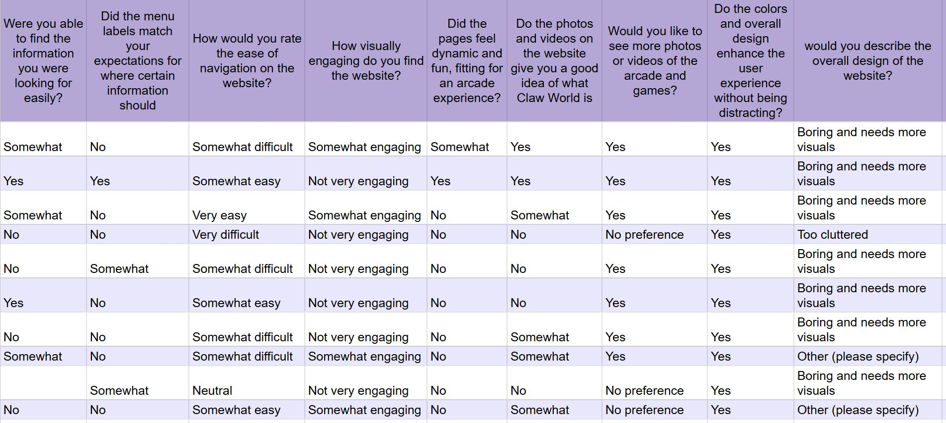
Figure 4 – Table of Overall Questionnaire Results

During
While we tested them, we collected information regarding the usability and the aesthetic appeal of the website. Specifically, we asked questions regarding the navigation, content organization, and visual aspects of the website.

Post-Testing
After each participant successfully completed their questionnaire, we gathered the data from each form and eliminated those who did not match our typical user profile. Once we collected the data from each form, we visualized it using graphs.

Findings
Based on our usability tests, we observed several key findings:
- Navigation difficulties - many users struggle to locate key pages, such as pricing and game tutorials.
- Dynamic Pages: Multiple participants reported slow-loading pages.
- Photos/Videos: While participants appreciated the inclusion of photos and videos, 40% noted that the videos were not very engaging or appealing. Additionally, they expressed that the phone portrait orientation was distracting.
- Visual Elements: Many participants felt that the website was underwhelming in terms of color usage and icons.

Conclusion
Based on our findings, we have drawn the conclusion that the website ClawWorldUSA.com left users feeling dissatisfied and/or disengaged in navigating the website, the visual elements, and the photos and videos on the websites. To remedy these user issues, we recommend that the website reorganize the menu options, update the visual design, and hire a professional photographer to upgrade the site's multimedia content. These solutions will help improve the user experience of the website, and in turn, attract more visitors and customers to the arcade. If you have any questions, please contact Katarina Hung. Thank you!

